HR Termination Process - Windchill NA Production

1. Overview
This document explains the HR termination process in Windchill NA Production, including user removal, license tracking, necessary ticketing, and communication steps.

2. Prerequisites
- A ServiceNow ticket must be created before performing this activity.
- Access to Windchill NA Production with necessary privileges.
- Excel template for sorting Employee IDs.
- Access to the Group and User Processed tracking workbook.

3. Data Preparation (Excel)
- Download the Excel file from the Workday ‘Click here’ link given in the email (which we receive every Sunday for the previous week) as attached below -
- Sort the EmployeeID column in sets of 20 (Windchill supports ~200 characters per search).
Use the following concatenation formula to build 20-ID search strings (fill-down):
B2 = A2 & ";" & B1
3.3 Use the prepared Excel template to automate the 20-ID grouping and copying.
Hr Termination Template -1.xlsx
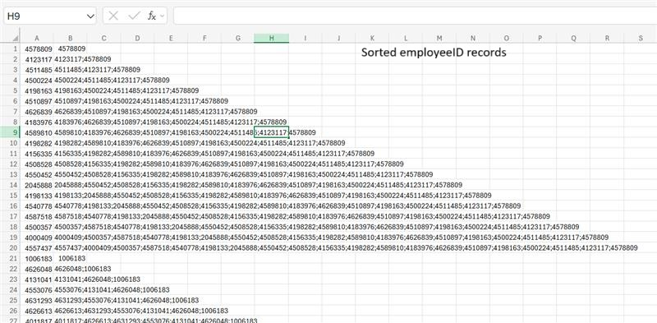
4. Windchill NA Production - User Removal Steps
Log in to Windchill NA Production, then perform the following steps:
https://windchill.fmcna.com/Windchill/app/
a. Browse → Site → Utilities → Participant Administration → Add Participants
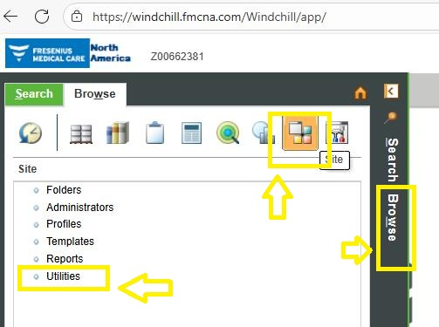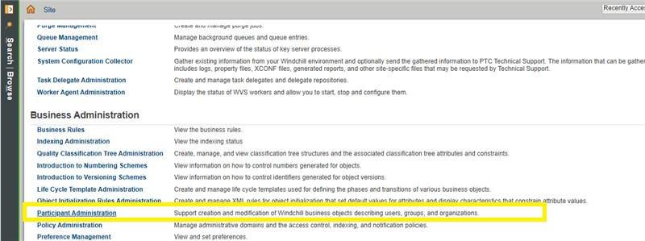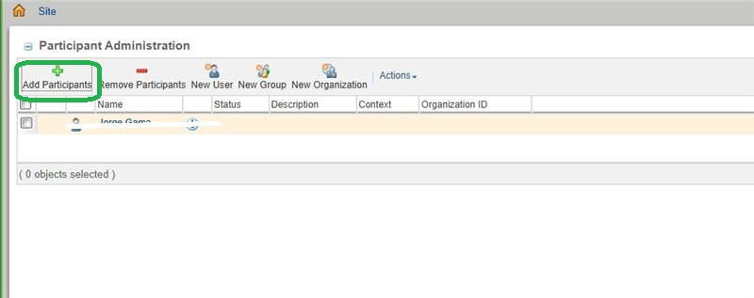
b. From the drop-down, select All Participants
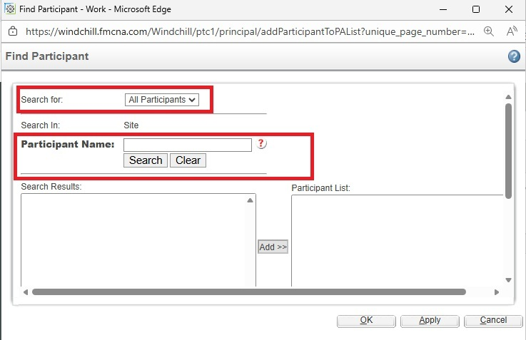
c. Search for users copied from the sorted Excel string
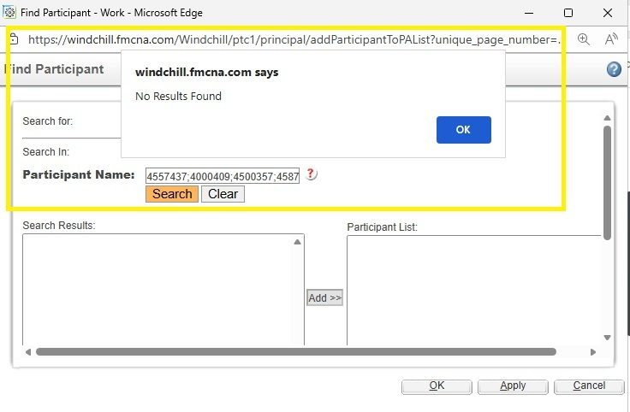
d. If a user is found, click OK to add to Participant Administration.
Before deleting, record the user's license details to update the Excel tracker.
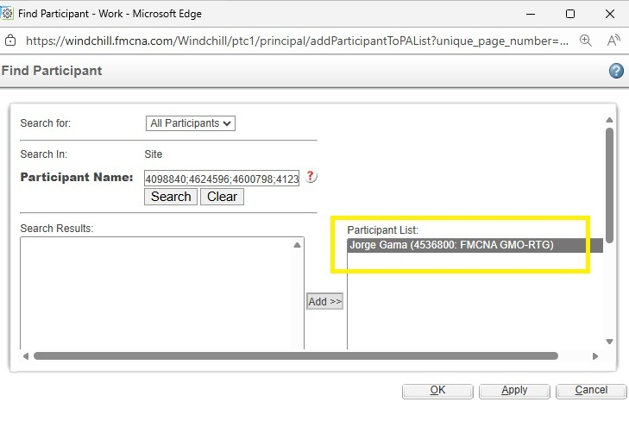
e. Action → Edit → Assign to Group → Select All → Remove → Finish
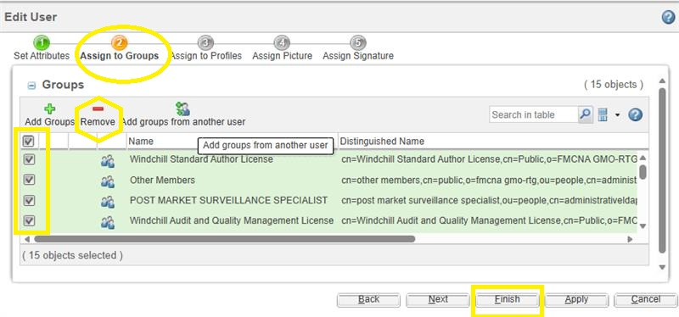
f. Action → Edit → Remove from Cache
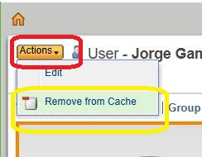
g. Return to Participant Administration page

h. Action → Delete from Windchill and Windchill Directory Server
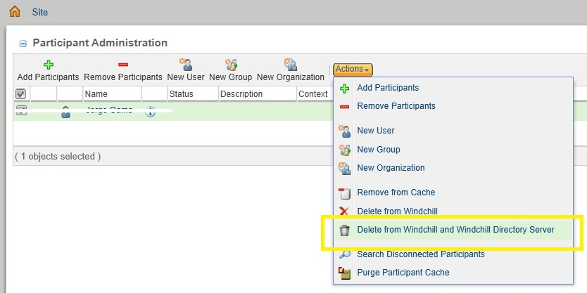
i. Browse → Site → Utilities → Personal Cabinet Administration
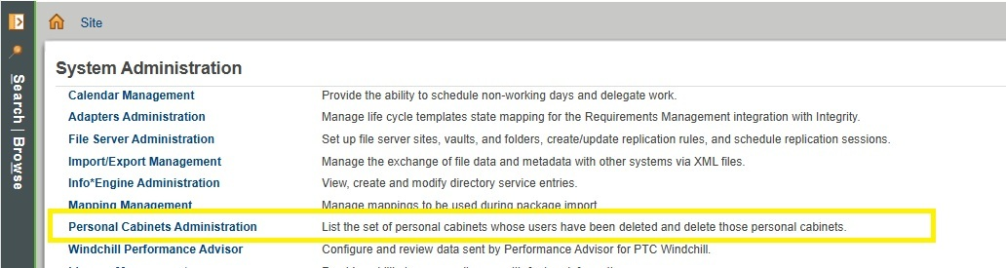
j. Search for EmployeeID in Personal Cabinet Administration and use Delete the User.
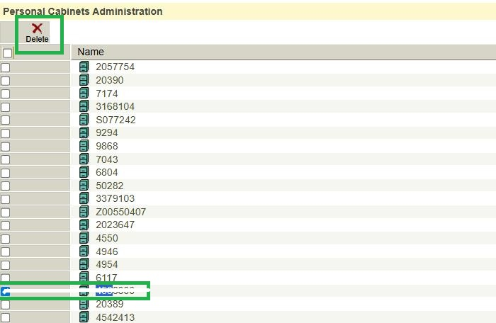
- Workflow diagram :
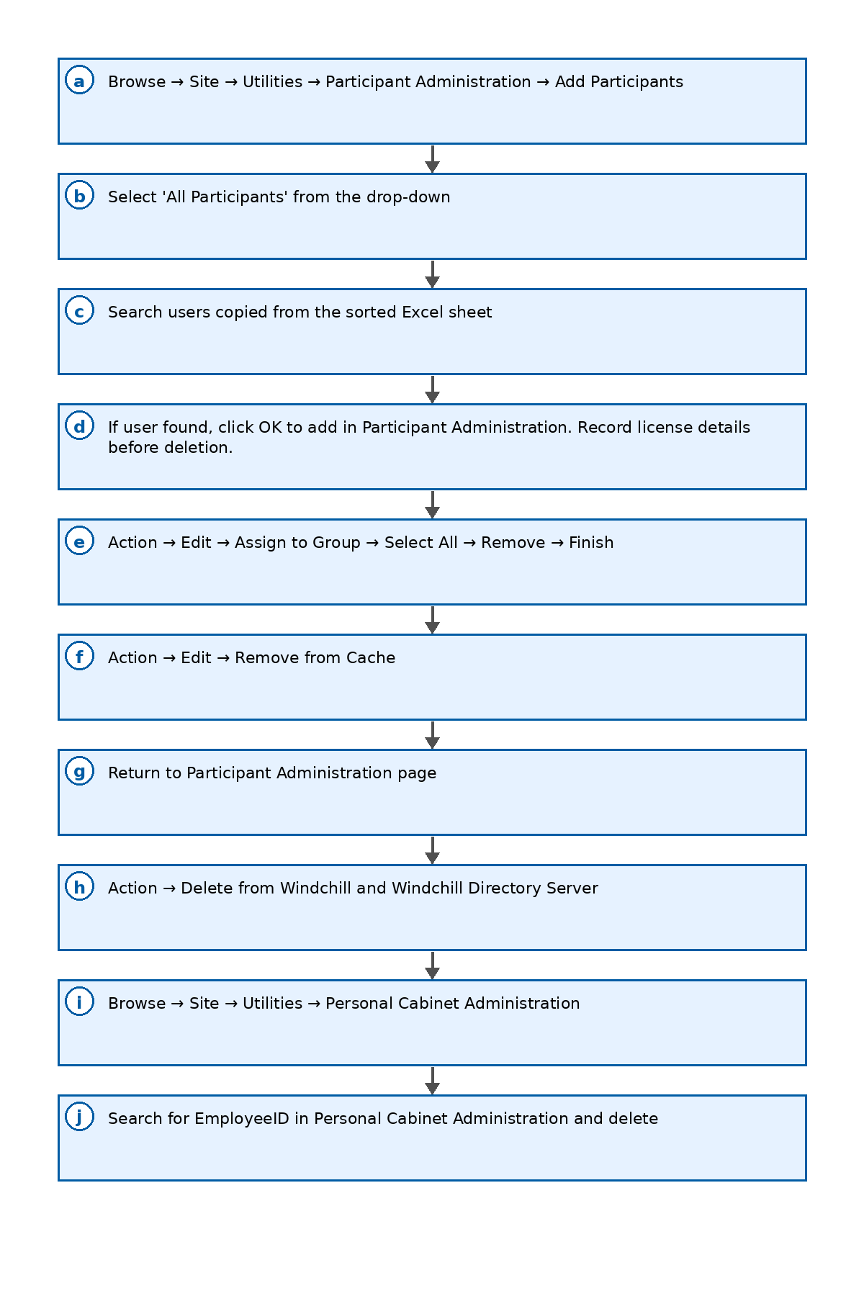

5. Post-Deletion Updates
- Update the users' licensing details in the "Group and User Processed" Excel tracker.
Group and User Processed
- Attach evidence (screenshots, logs) to the ServiceNow ticket.

6. Communication – Email Template
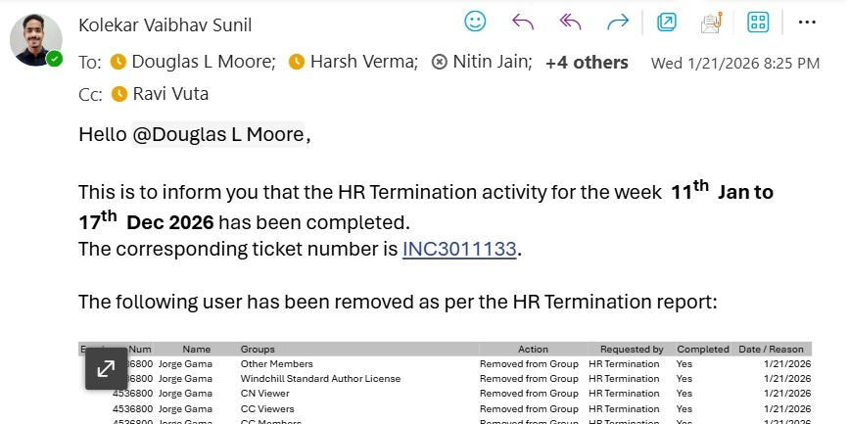

7. ServiceNow Ticketing
- Create a ServiceNow ticket prior to performing the activity (include scope, dates, approvers, and risk).
- Attach Excel evidence and close the ticket upon completion, adding a clear work note summary.
